**273/1**

GEOGRAPY

Paper1

**2024**

45 minutes



S.1 END OF TERM 1 EXAMINATIONS 2024

Uganda Certificate of Education

GEOGRAPHY

Paper1

45 minutes

INSTRUCTIONS:

Answer any one question.

ITEM 1. Map skills

For this item use the East Africa 1:50,000 (Uganda) map extract of Kijura series Y732, sheet 56/2, Edition3-U.S.D, the information in the text below and the support materials in Fig. **1** provided to answer the tasks given:

The communities living in Hakibaale one of the sub-counties shown on the map extract of Kijura, carry out different activities especially in areas East of Easting 07 and South of Northing 96. These activities have enabled the people to survive but also impacted on environment. The local authorities have opposed some of those activities and are planning to set up laws governing their operation. The community is confused because they do not know the effects of their activities on the environment and what they need to do to conserve it.

Task:

1. Identify any two activities carried out for survival in the area above. (03 marks)
2. Make a write up advising the community found in Hakibaale sub-county on the map extract of kijura. (07 marks)

Item 2

Study the text below and answer the task that follows:

Katulume john one of your classmates in s.1 is showing no interest in geography as a subject. Often times, he reads or does tasks in other subjects during the geography lesson. When asked why he is showing no interest in the subject, katulume says he is not yet convinced as to why he has to study geography as a subject.

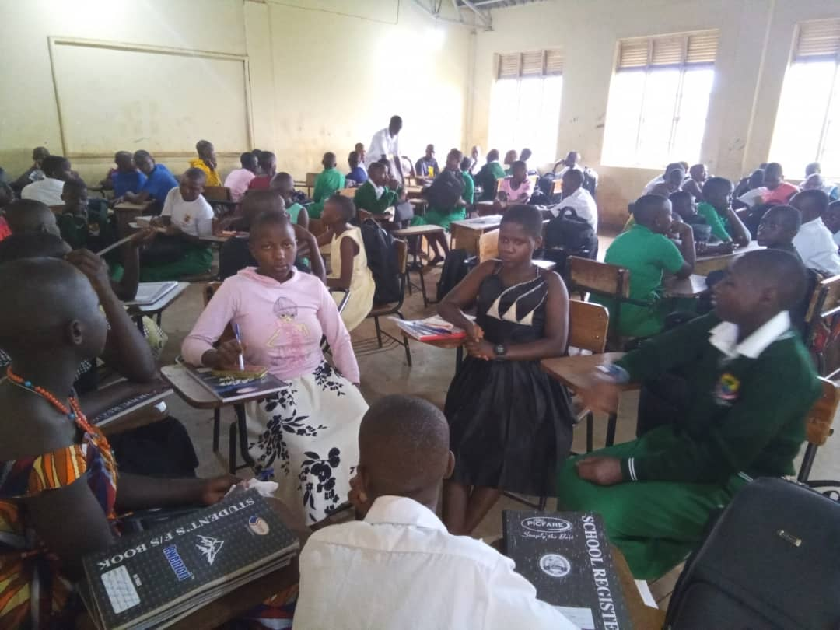

Task:

Prepare a message to be delivered to this classmate of yours. (10 marks)